**5 - R710 Proxmox update 6.2 to 6.3**

1. Proxmox 6.2 initial screen:  
   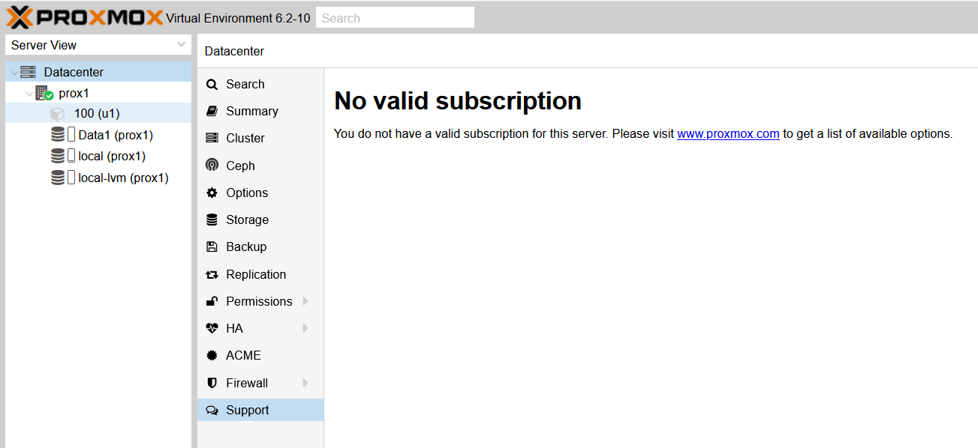
2. Open on main node level, and enter: **nano /etc/apt/sources.list**  
   to see:  
   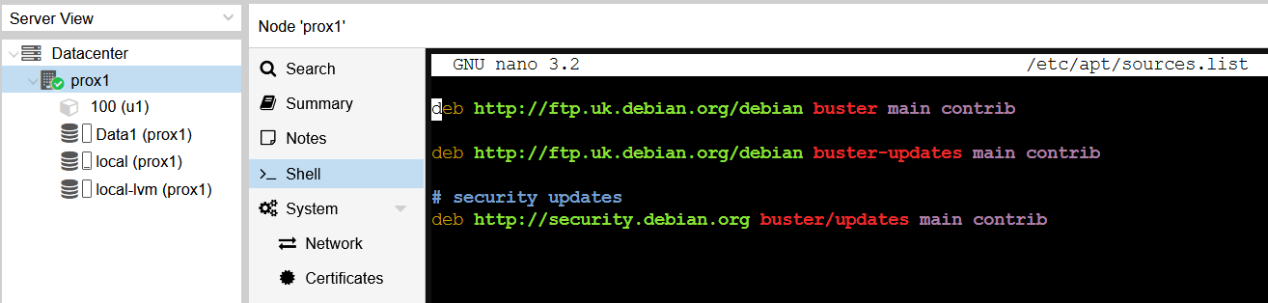
3. Edit this by adding:  
   **# PVE pve-no-subscription repository provided by proxmox.com,**

**# NOT recommended for production use**

**deb http://download.proxmox.com/debian/pve buster pve-no-subscription**

to get:

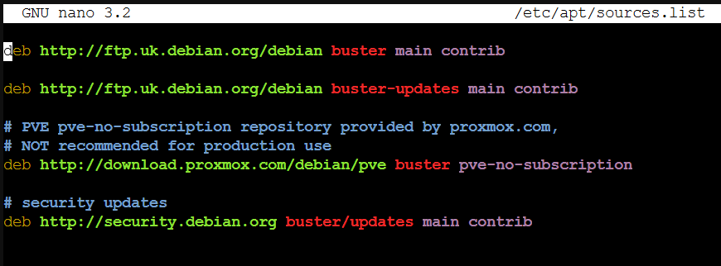

And save.

1. Enter:  
   apt-get update
2. Enter:

apt dist-upgrade

1. Work through the previous “Remove annoying nag popup”